SPHERICAL POWDER FOR THE MANUFACTURE OF PARTS USING SELECTIVE LASER MELTING (SLM) TECHNOLOGY IN 3D PRINTERS
NICKEL/STAINLESS/COBALT-CHROME/TITANIUM ALLOYS
GH4648 | INCONEL 718 | INCONEL 625
HASTELLOY X | INCONEL 713 | HAYNES 188
RENE 95 | WASPALOY | RENE 125
MOLYBDENUM -MO | TUNGSTEN W | TANTALUM TA
NIOBIUM Nb | GOLD - AU 75% | SILVER - AG 93%
PLATINUM PT-93.5% | AISI 316L | AISI 321
SUPERDUPLEX,SAF2507 | 17-4PH | W6MO5CR4V2(М2)
CoCr28V6 | COCRMO | COCRMOW
COCRW | NICR | NITINOL (NITI),
INVAR 36 | H13 | 4CR13
TITANIUM Grade5 ( TI6AL4V), | TITANIUM (TA-15), | ALUMINUM -AL6061
AL2024 | ZL104 | ALSI10MG

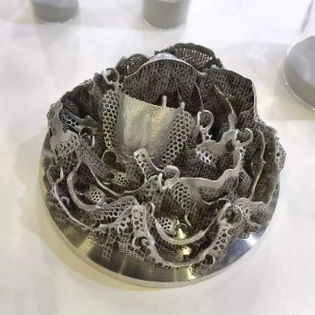
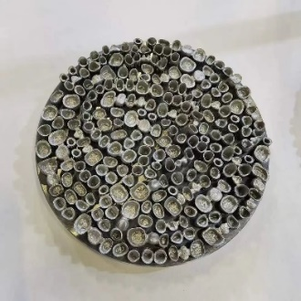
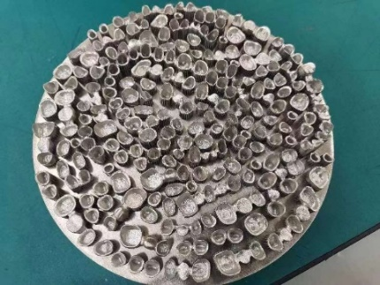
Particle sizes: 0-15µ/0-45µ/15-53µ/10-63µ/50-105µ/45-150µ.
